M3 INVENTORY
- Open back of tricoder and insert THREE AAA batteries.
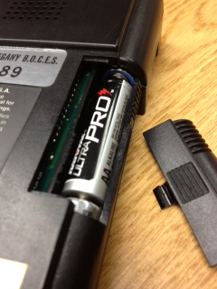
- Attach scanner wand to tricoder in the bottom side connection:
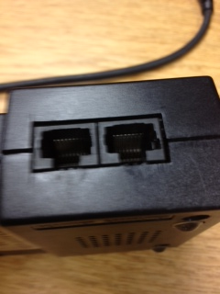
- Turn tricoder on by hitting the GREEN ON/OFF button.
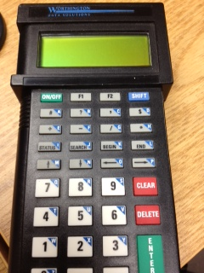
- Hit ANY key.
- Hit ENTER/YES GREEN key for YES to “Data Collection.”
- Hit the ZERO (0) button for PROGRAM NO.
- Scan books. You can roughly scan around 2000 books before you need to upload. If the tricoder turns off, you do NOT lose your data. If the batteries die and you change them, you do NOT lose your data. Simply change batteries or turn scanner back on (if you’ve left it to do something else, the tricoder automatically turns itself off after 5 minutes or so) and hit ANY KEY. Hit YES to “Data Collection” and then YES if it says on screen “DATA FILE ALREADY EXISTS.” Then scan away.
- When done scanning and are ready to upload, attach WEDGE SAVER to computer in any USB port (front or back of computer.
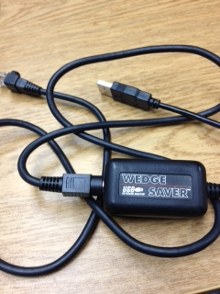
- Attach the other end of the WEDGE SAVER to the tricoder in the top side connection (above scanner connection).
- On computer, OPEN INVENTORY and login.
- Click on CREATE NEW SESSION.
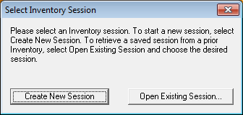
- Go to ACTION, and INVENTORY OPTIONS (on top of screen).
- Type in your School’s name (if not already there) and then hit “NEW PATTERN” if your barcode patterns don’t already show up:
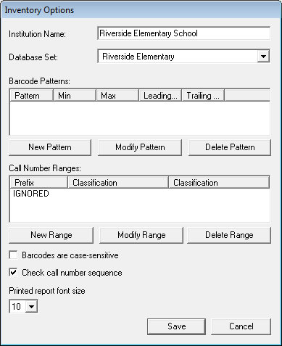
UNCHECK the box for “Check call number sequence”
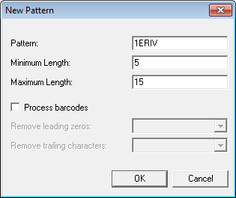
If you need to add a barcode “NEW PATTERN”, click the button and then fill in like above (FIRST 3-4 LETTERS OF BARCODES and THEN LENGTH). Hit OK.
- Go to FILE.
- Select “UPLOAD FROM READER.”
- This box will appear:
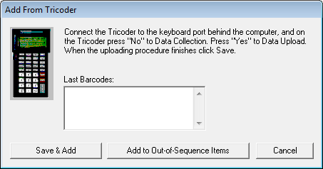
Make sure your cursor is inside the box above and then on the tricoder:
HIT F1
HIT NO to data collection
HIT YES to data upload.
You should then see your barcodes scrolling in box above.
- When the upload is done, hit YES on tricoder to delete the file. Hit YES for “are you sure” and hit YES for data collection, and 0 (zero) for program number. Then scan more books.
- On COMPUTER, hit SAVE & ADD and when the box appears, USE DROPDOWN box to choose C: drive, PROGRAM FILES, MANDARIN LIBRARY AUTOMATION, M3, INVENTORY and then create a new folder inside the inventory folder to save your uploads. SAVE your file with the name of what you just scanned. (EX: REF, FIC A-G, EASY, 000-399, etc.)
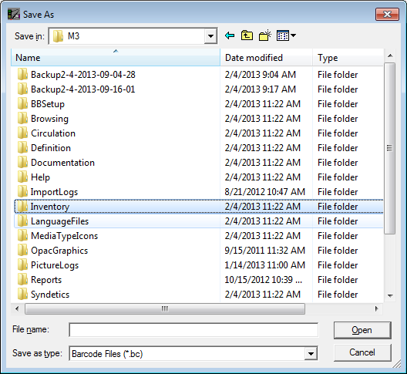
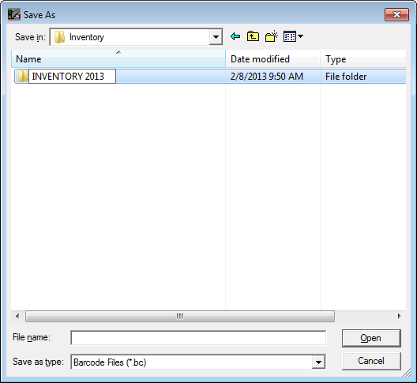
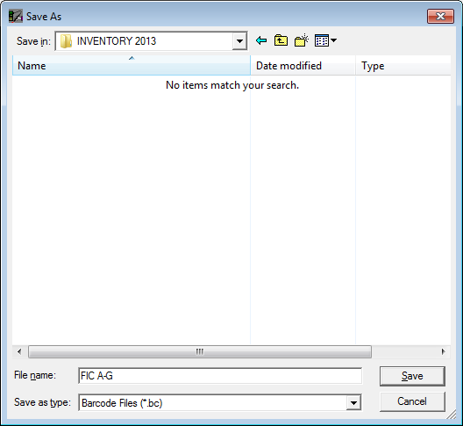
Hit SAVE and then detach tricoder from computer and scan more books.
- In INVENTORY module, go to FILE and SAVE SESSION after every single upload!
- When you are all done with uploading barcodes, go to ACTION and DO INVENTORY.
- You can, when it’s done, click on the different tabs along the bottom of the screen for the different reports. You can then print the ones you want.

REPORTS:
- Newly Found: these are books that were missing in the past and are actually on the shelves now. You can mark them all as PRESENT by going to ACTION and choosing MARK NEWLY FOUND. This is all you have to do with this report.
- Missing: Obviously you know what this report contains. You can go through to see if sections of your library were missed, and rescan/rerun the inventory process if you have a lot of missing. Also, you can go to ACTION and choose MARK MISSING ITEMS if you want. This will add the 994#a field to the holding record of each book and mark them as missing. If you then find the book, change the 994#a to NORMAL or scan it in circulation in the STATUS column and it will automatically change the book to present instead of missing.
- Invalid Barcodes: These are barcodes that were scanned during inventory that are NOT in your catalog. Find these books and add them to Mandarin in cataloging.
- Loaned Shelved: these are books that are on your shelves but are still on loan to a student/teacher in circulation. Return these books in circulation.
- No Barcode: this report shows any bibliographic records in your catalog that have no holdings. If they are eBooks, cross them off the list. If they are actually records for books that you have no holdings for, delete them in your catalog. If they are actual books that you have in your library, add the holding records.
- Duplicate Barcode: this is a report that would show you if you have two holding records with the same barcode number in it. This rarely happens with M3 now. If you have duplicate barcodes, figure out which book actually has the number and change the other.
- Out of Range(s): is for partial inventories where you do a single range at a time (FIC only, etc.) and will show out of sequence books.
- Statistics: print this if you want. Shows how many books you scanned, etc.

